Blowing up a Balloon with a Bottle- science for kids
What to do:
pour vinegar in plastic bottle about 1/3 full using funnel. Use the other funnel to pour baking soda into balloon about 1/2 full. Now take the balloon and pinch as you wrap on the top of the bottle so that none of the baking soda goes in just yet. Once you have the balloon on the top of the bottle lift the balloon up causing the baking soda to pour out into the bottle. This causes a gas reaction that makes the balloon blow up.
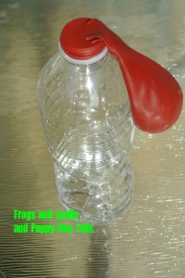
This is how you want your balloon on the top, so when you pick it up the baking soda falls in the bottle.
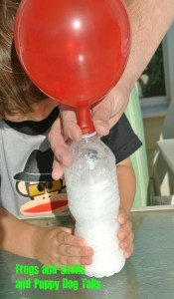
And it is off, the balloon is blowing up with the carbon dioxide gas the vinegar and baking soda create.

