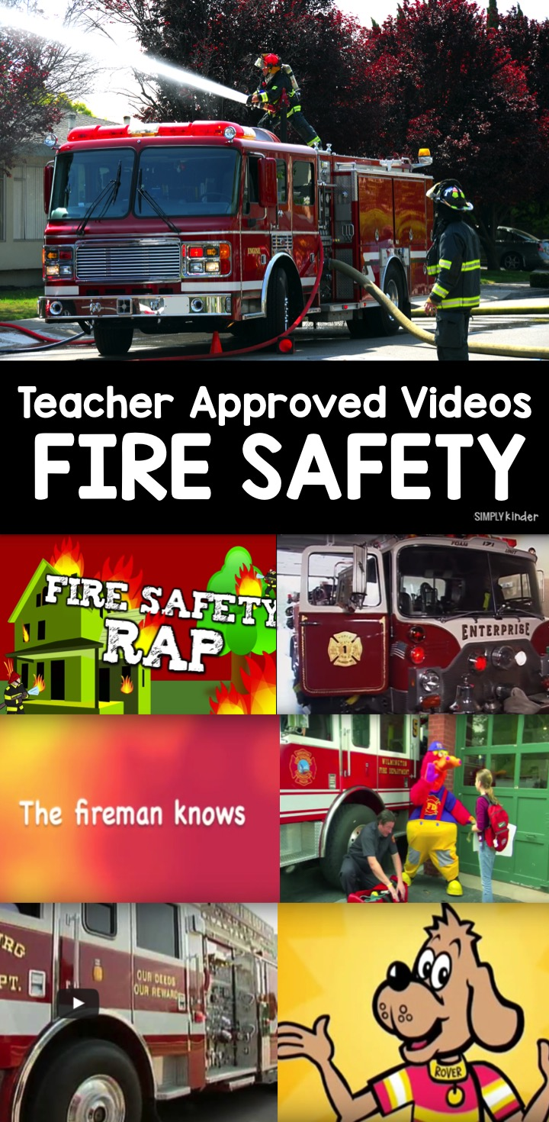
It’s fire safety week and we are here to help with some Fire Safety Videos for Kindergarten. This list of videos covers a range of topics including fire safety and working as a firefighter.

SAFETY FOR CHILDREN: THE FRIENDLY FIREMAN (4:57)
https://youtu.be/ovWF4MU25Z8

This is a very straightforward video about do’s and don’ts with all things fire safety.

STOP, DROP, AND ROLL BY VICTOR JOHNSON (1:53)
https://youtu.be/JJlSJokQE4g

SUPER SMART FIRE SAFETY RULES (6:59)
https://youtu.be/JJlSJokQE4g
Another great video loaded with details about fire safety at home. This one does a really great job of reinforcing some of those details like not opening a door if the door is hot and what to do. They remind kids to to talk to their parents about specifics like how to get out if you are on the second floor of your home. It also has lots of questions so the kids can think and answer along with the video. It ends with a fun “Stop, Drop, and Roll” song with motions. Kids will love the little character in this video as well.

SAFE KIDS: I SPOT SOMETHING HOT (8:26)
https://youtu.be/r4w7ub5RJeA

This is a great video about things in your house that are hot and kids should not touch. It’s a little drawn out, but it definitely gets the point across and gives the kids some great practice.

FIREFIGHTER GEAR WITH SPARKY THE FIRE DOG (3:18)

https://youtu.be/Lzb9v2iQH4o
Get Sparky the Fire Dog prepared to fight fires with all the right gear. This video is great for teaching kids not to be afraid of firefighters.

COOL BIG FIRE TRUCKS (2:49)
This is a great video showing TONS of fire trucks in action. It’s fast paced so the kids won’t lose interest!
​ https://youtu.be/Lzb9v2iQH4o

FIRE SAFETY RAP! BY HARRY KINDERGARTEN (3:14)
https://youtu.be/s_5FqaWTj9c https://youtu.be/s_5FqaWTj9c

This is a great Harry Kindergarten video that covers everything about fire safety with a catchy chorus your kids will love. It covers everything from having an escape plan to not being afraid of firefighters.

