Fluffy Pumpkin Slime

All activities should be supervised by an adult. By using this site, you agree to our Terms of Use. This post may contain affiliate links. Read our disclosure policy here.
Slime is one of our favorite science activities and we like to make it holiday-themed when we can! This fluffy pumpkin slime is a perfect Fall and Halloween science activity with kids! We’ll even show you how to turn your slime into a jack-o-lantern pumpkin! Kids will love playing with this fluffy slime for Halloween. This would also be perfect to make for a Halloween party or sensory activity.
RELATED: Halloween Slime
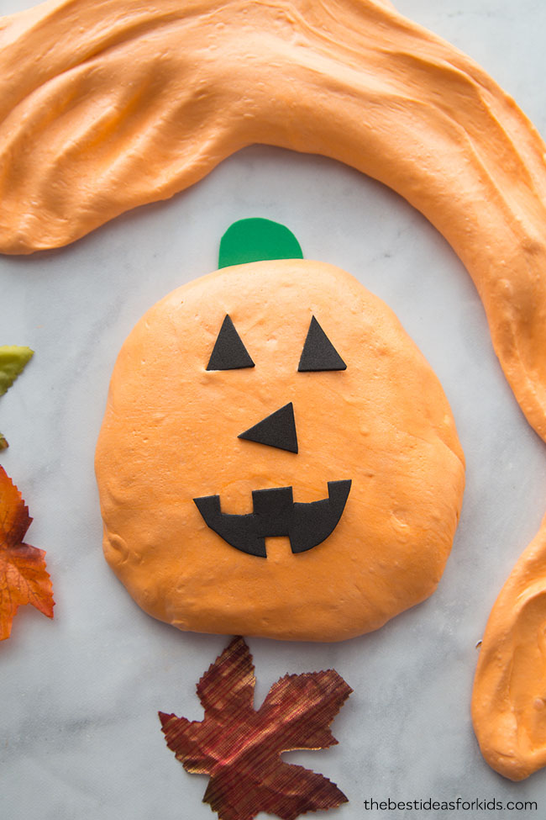

If you’re looking for some Halloween activities to do with your kids this year, making slime can be a fun sensory activity! You can even do a craft day where you make slime and some Halloween jars to go with them. See how to make a pumpkin, ghost and Frankenstein Halloween slime jar here.

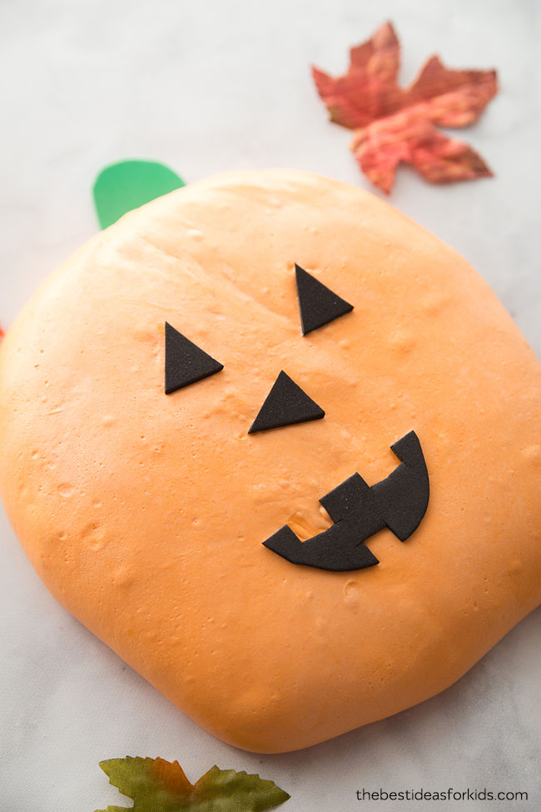

Pumpkin Slime
We love how simple fluffy slime is to make! Our recipe has been developed to make it a little more stretchy than other fluffy slime recipes you may try. We add in water to help with this. If you want it less stretchy, you can skip the water. At first it will feel really sticky when you’re making it – and that’s normal! It requires a lot of kneading before you get the consistency that makes it less sticky. You can always add a little more contact solution if you still find it sticky but we recommend trying to knead more first so you don’t make the slime too hard.
OUR LATEST VIDEOS

01:09
01:59
Also keep in mind that any fluffy slime loses its “fluffiness” after a day. It’s still fine to play with the next day, but it just won’t be fluffy anymore.

What is Pumpkin Fluffy Slime?
Fluffy slime is regular slime made with shaving cream. The more shaving cream you add, the fluffier it will be. For this activity we recommend only 2 cups so that you can make it into a jack-o-lantern. If you add too much shaving cream it will be harder to form into a pumpkin shape.
If you want to make sure your slime turns out – be sure to read the instructions carefully. The type of contact lens solution you need and glue is very important! Substituting these ingredients for other brands may result in your slime not working. We also advise against substituting the brands we recommend.

Fluffy Pumpkin Slime Recipe
If you’re looking for a general slime recipe, our base slime recipe can be found here: How to Make Slime With Contact Solution. We like to use contact lens solution instead of pure borax in our slime recipes. If you’ve never made slime before, we recommend you make this Halloween slime first.
We recommend adult supervision and that adults only should make the slime. See more safety tips at the bottom of this post before making your slime.
Once you have your fluffy slime made, have fun stretching and squishing it. Fluffy slime is a bit harder to stretch than regular slime. It’s made more for the sensory experience of pressing and squishing the slime.

How Long Does This Slime Last?
The shaving cream will settle and the next day your slime won’t be as “fluffy”. The slime will still be fine to keep and store. You can still play with the slime after the first day, it will turn into a consistency more like regular slime. Store in an air tight container or re-sealable bag and your slime should last at least 1 week.
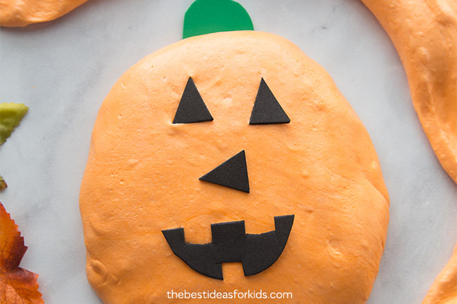
What is Slime?
Slime is a polymer because it has qualities of both a solid and a liquid. Other examples of polymers are Jell-O, gum and rubber bands. Glue is also an example of a polymer. A polymer is made of long chains of polyvinyl acetate molecules. These chains slide easily between one another making the substance pour-able.
The Science Behind Slime
Making slime is fun for kids but it’s also really cool science! Explain the science to your kids when you mix the contact lens solution with the glue. When you add the contact solution to your glue, it counteracts the glue and forms a viscous substance. This turns into slime and can be shaped and stretched. The slime forms when the glue molecules cross-link with the borate ions in the contact lens solution. This is a bond that causes the large molecules to no longer slide freely past one another (like the substance was when it was a glue). Therefor resulting in slime!

Pumpkin Slime Ingredients
– 2/3 Cup of Elmer’s White Glue – we like to buy this gallon size of white glue since it’s a value size.
Note: we made this with Elmer’s white glue. Do not substitute with other glue as the make-up may not be the same and the recipe may not work
– 1/2 Teaspoon Baking Soda
– 1/4 Cup Water
– Liquid Food Coloring – this set comes with a vibrant orange
– 2 Cups Shaving Cream – Note: do not use shave gel.
– 2 Tablespoons Contact Lens Solution – *Important: your brand of contact lens solution must have boric acid and sodium borate in the ingredient list. This is what interacts with the glue to form the slime. We recommend using Renu fresh or Equate brand. Do not substitute with other brands.
SEE: How to Make Slime With Contact Solution for more tips making slime with contact lens solution.
Safety Tips: Adults only should make the slime and handle all chemicals. Do not substitute any ingredients in our slime recipes. If you have sensitive skin, wear gloves while playing with the slime. Always wash hands before and after use. If you notice any skin irritation discontinue use immediately. Slime is a science experiment and should be made and played with in moderation. See the bottom of the post for more safety precautions before making the slime.

How to Make Pumpkin Slime
1. Add your white glue to a bowl. Then add your baking soda and mix.
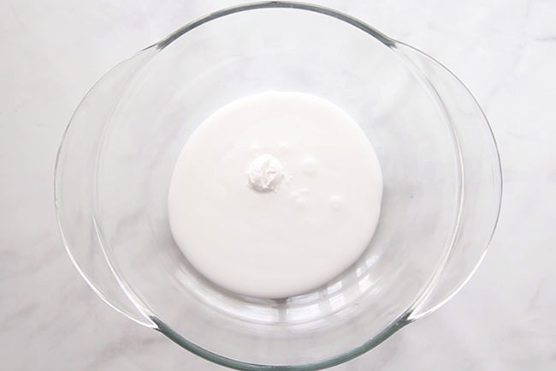
2. Add your water in and mix.
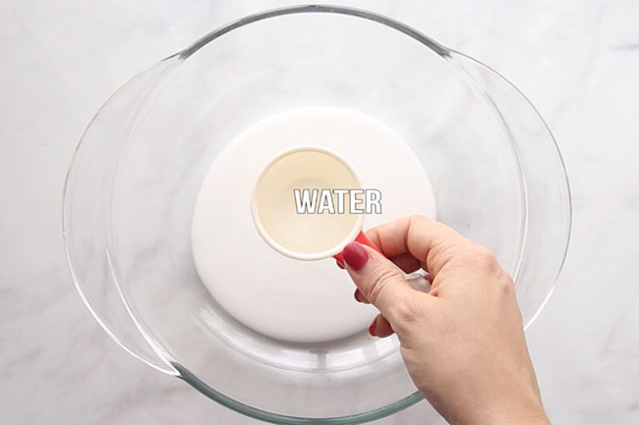
3. Add in your orange food coloring and mix. We recommend a gel food coloring like this set which is more vibrant and requires less food coloring to work.
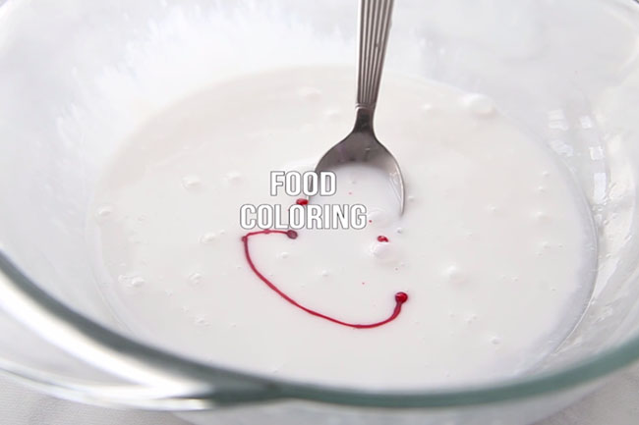
4. Add in the shaving cream and mix. Your color may become a lot less bright so if you want it to be a more vibrant orange add in more food coloring.
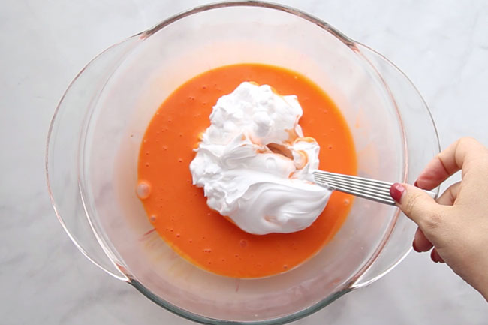
5. Now slowly add in your contact solution.
**Important: your brand of contact lens solution must have boric acid and sodium borate in the ingredient list. This is what interacts with the glue to form the slime. If slime does not form it is typically due to the contact lens solution not having these ingredients. Check your label and see the recommended brands above in our ingredient list.
We like to add in 1 tablespoon, and then mix. Then add in the remaining tablespoon and continue mixing. Once the slime pulls away from the bowl, take it out of the bowl and knead for 10 minutes. The slime will be very sticky when you’re kneading – and that’s normal!
Note- fluffy slime is MESSY when you’re making it. It is normal that it will stick to your hands when kneading. Keep kneading for at least 10 minutes. It can also help to let the slime “rest” for about 5 minutes on the table before you play with it.
If you are finding it is still too sticky after kneading then add some baby oil or lotion to your hands. You can also add more contact solution but we recommend adding only 1 teaspoon at a time. If you add too much, the slime may become hard.
6. Now make your pumpkin! Get your slime into a pumpkin shape. Cut out the eyes, nose and a mouth from black foam paper. Add a stem to the top with green foam paper. Kids can have fun switching out the faces they add to the jack-o-lantern if you want to cut out all sorts of eyes, nose and mouth options.
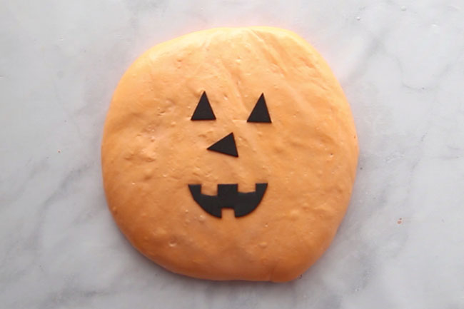
Watch the full tutorial video here before you get started!

Now it’s time to play with your pumpkin slime! Your pumpkin slime should last at least one week if stored properly (see storage details above in the post).

Slime Safety & Precautions
Note: Making slime is a science experiment and safety precautions should still be made when creating slime. By making this slime, you agree to our site terms which you can read here.
- Adults should handle any chemicals and products
- Adults should make the slime
- Always read and follow the labels of products used. If contact lens solution is accidentally ingested, seek medical attention immediately.
- This project is not suitable for children under 4.
- Slime should not be placed in the mouth. Always wash hands before and after playing with the slime.
- If you notice any skin irritation, discontinue use immediately. If you have sensitive skin, wear gloves while making and playing with the slime.
- Slime is a science experiment and should be made and played with in moderation. Do not allow children to make their own slime and do not play with slime for an extended period of time.

