OCTOBER 7, 2017 3

50+ Halloween Crafts for Kids

All activities should be supervised by an adult. By using this site, you agree to our Terms of Use. This post may contain affiliate links. Read our disclosure policy here.
With Halloween just around the corner, what better way to get into the Halloween spirit but then to do some fun Halloween Crafts for Kids? You have come to the right place at The Best Ideas for Kids to get inspired with so many fun Halloween activities and crafts for your kids! We’ve gathered over 50+ of our favorite Halloween kids crafts. Which one is your favorite?
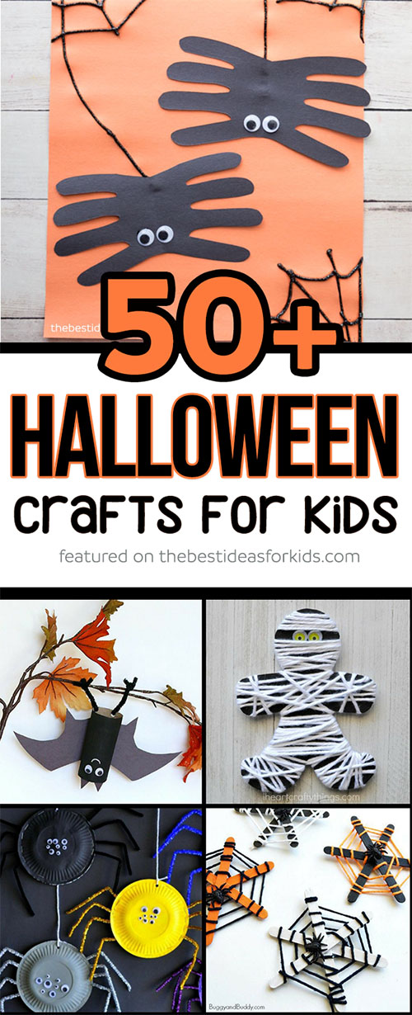

50+ Halloween Crafts for Kids
We’ve broken down the crafts into different sections for you to make it easy to find the perfect Halloween craft for your kids!

Pumpkin Crafts for Kids
Pumpkins have to be one of our favorite crafts around halloween. We especially like to make the pumpkin slime and have fun playing with it afterwards!
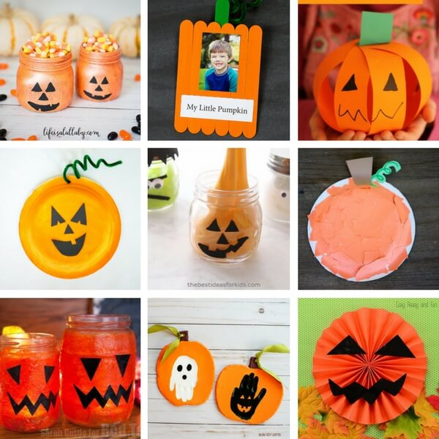
1. Pumpkin Mason Jar Craft
OUR LATEST VIDEOS
2. My Little Pumpkin Keepsake Craft
3. Paper Strip Pumpkins
4. Build your own Jack-O-Lantern
5. Halloween Pumpkin Slime
6. Paper Plate Pumpkin Strips Craft
7. Jack-O-Lantern Jars
8. Handprint Clay Pumpkins
9. Paper Pumpkin Craft
And for a fun no-carve pumpkin decorating idea, be sure to see our melted crayon pumpkin tutorial.
RELATED: 15 Pumpkin Crafts for Kids

Spider Crafts for Kids
There are so many fun spider crafts listed below – from handprint spiders, moving spiders, climbing spiders and craft stick webs!
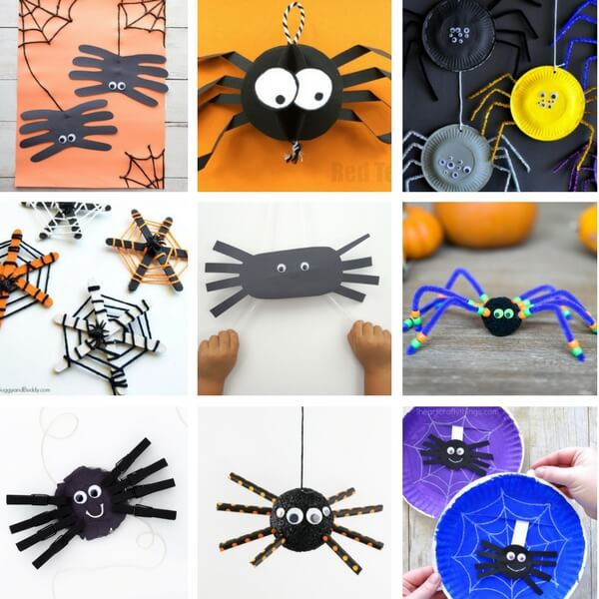
1. Spider Handprint
2. Paper Spider Craft
3. Paper Plate Spiders
4. Craft Stick Spider Webs
5. Climbing Spiders
6. Pom Pom Spider Kids Craft
7. Mason Jar Lid Spiders
8. Spider Foam Ball
9. Paper Plate Moving Spider
And if you haven’t seen the video of our spider handprint, hop over to the post to see how it’s made in action!

Mummy Crafts for Kids
Making mummies can’t be any easier! Grab some yarn, paper, gauze or tape and voila you have some pretty impressive mummies to share. And don’t forget the googly eyes!
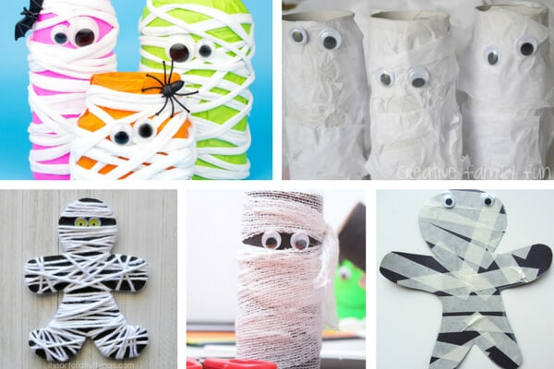
1. Neon Mummy Jars
2. Cardboard Tube Mummies
3. Yarn Wrapped Mummy Craft
4. Gauze Paper Roll Mummies
5. Masking Tape Mummy Craft
RELATED: See these adorable mummy cake pops – such a fun treat for Halloween!

Witch Crafts for Kids
Who says witches have to be scary? These friendly witches for Halloween will keep your kids busy! We especially like the handprint witch card (it opens up to let you write a message inside!).
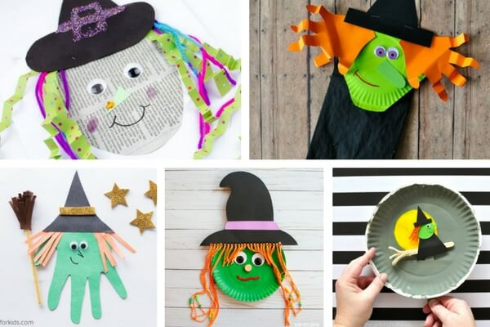
1. Newspaper Witch Craft
2. Paper Bag Witch
3. Witch handprint craft
4. Paper Plate Witch
5. Paper Plate Flying Witch Craft

Bat Crafts for Kids
We think these bat crafts couldn’t be any cuter! The egg carton bats would look great hung up for a halloween party! And attach some of the paper tube hanging bats to your plants around the house too!
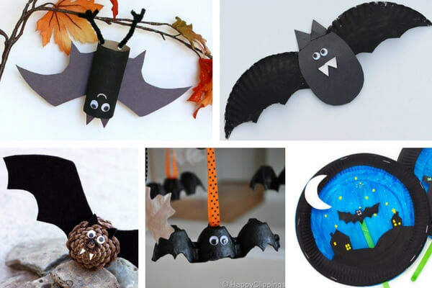
1. Hanging Bat Craft
2. Paper Plate Bat
3. Pinecone Bats
4. Egg Carton Bats
5. Paper Plate Flying Bat Craft

Black Cat Crafts for Kids
These black cat crafts are perfect for Halloween but you can also have fun making them anytime of the year! Just change the color and make colorful cats too.
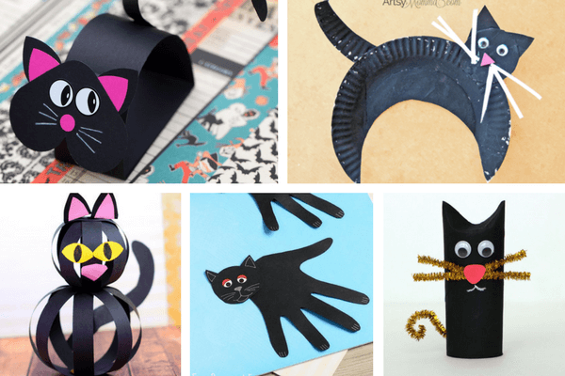
1. Paper Bobble Black Cat
2. Paper Plate Black Cat
3. Cat Craft with Paper Strips
4. Handprint Black Cat
5. Paper Tube Black Cat

Ghost Crafts for Kids
Finally we have our favorite ghost crafts from cotton balls to handprints these ghosts are more friendly than scary!
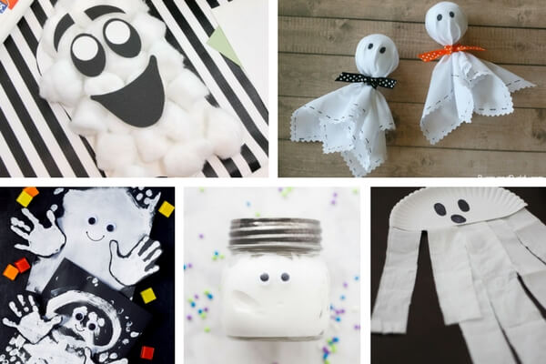
1. Cotton Ball Ghost Craft
2. Easy Fabric Ghosts
3. Handprint Ghosts
4. Ghost Slime Jar
5. Paper Plate Ghosts
RELATED: See these easy spooky halloween cookies and ghost marshmallow treats!
Looking for more Halloween crafts for kids? Check out these other fun Halloween craft ideas – perfect for toddlers or preschoolers too!
- Cardboard Zombies
- Trick or Treat Bags
- Halloween Doodle Books
- Sugar Skull Rocks
- Paper Plate Day of the Dead Craft

