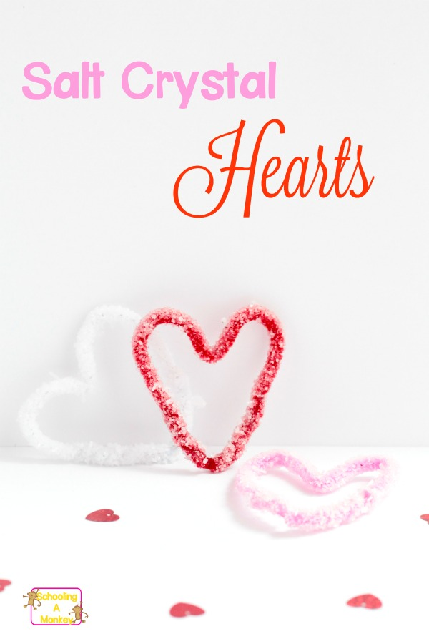
in SEASONAL· STEM· VALENTINE'S DAY
Salt Crystal Hearts: Valentine’s Day Science Experiment for Kids

This Valentine’s Day, make your valentine these adorable salt crystal hearts! How are they made? Find out in this simple science experiment!

We love simple science projects, and one of our favorites has been making salt crystals. These crystals are low-cost and turn out perfect nearly every time! This time, make salt crystal hearts for Valentine’s Day science learning.

Salt Crystal Hearts: Valentine’s Day Science Experiment for Kids
Try this fun Valentine’s Day themed science experiment and combine learning with the holiday of love. This post contains affiliate links at no cost to you for your convenience.

What you’ll need to make salt crystal hearts:
- Salt
- Glass mason jars (1 for each heart)
- chenille stems (1 for each heart)
- Clothespins (1 for each heart)
- String
- 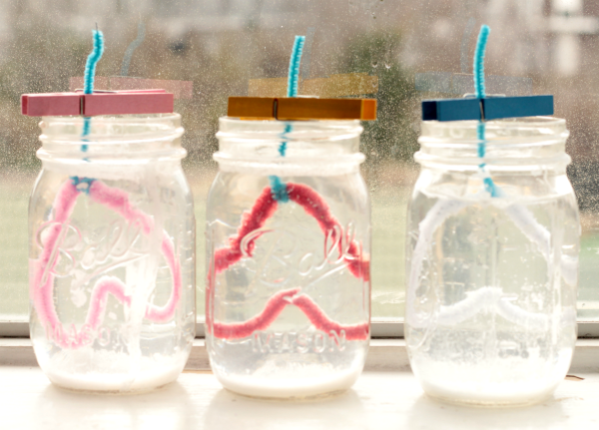

Fill your jars about 3/4 of the way full with water. Dump this water into a pot on the stove. Heat the water until it boils. Slowly add salt into the pot until no more salt can dissolve in the water and crystals start to form on the surface of the water. Remove from heat.
Fill the mason jars 3/4 of the way full of the salt water.
Bend a chenille stems into the shape of a heart. Make sure the heart can fit through the mouth of the jar. Once the crystals form it will be hard to get it out of the jar if it is too big.
Tie a string (or you can use another chenille stem) to the point of each heart. Use a clothespin to suspend the heart in the center of each jar.
Set the jars in a sunny place and let the crystals start to form. The longer you leave them, the more they will grow! We recommend leaving your salt crystals to grow for at least three days.
Take this further by comparing the size of crystal formation after 24 hours, 48 hours, 72 hours, and a week. How much bigger are the crystals after a week? Carefully remove the crystals from the water and let them dry on a paper towel.
When salt water evaporates, the water can no longer hold all of the salt molecules. When this happens, the salt crystals cling to anything nearby, including the rim of the jar and the chenille stems inside of the jar. Over time, as the water evaporates, the salt crystals get bigger and bigger, making pretty, square crystals that are amazing to look at! Use a microscope to investigate these salt crystals up close for even more science fun!

