- Home
- Resources & Tools
- Strategies & Ideas
- Student Activities
- Books & Authors
- Products & Services
- Storia®eBooks
- ShopThe Teacher Store

Crafts

Mosaic Indian Corn Craft

Students create striking decorations for Thanksgiving using dozens of little colored squares.
By Jennifer Solis
- Grades: PreK–K, 1–2, 3–5
- Print
- Share

- Tweet

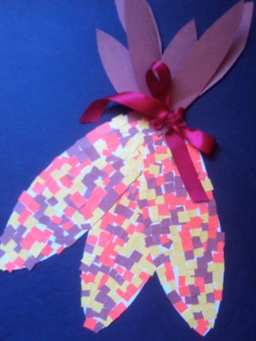
Students experiment with colors and patterns as they design their own mosaic for Indian corn.

What You Need:
- White construction paper
- Scissors
- Yellow, orange, and brown construction paper, cut into small pieces
- Full sheets of brown construction paper
- Glue
- Stapler
- Red ribbon
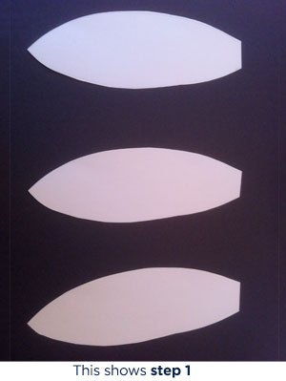
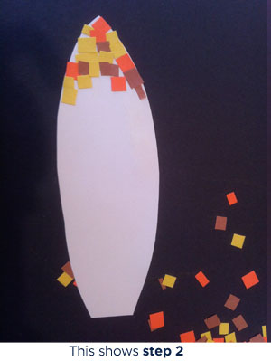

What You Do:
- Have students cut three oblong corn shapes out of the white construction paper, one end pointed and one squared off.
- Have students glue the small pieces of yellow, brown, and orange construction paper to the white corn shapes. Try to glue the pieces so that the sides are touching without too much overlap.
- Once the three corn shapes are covered with the mosaic pieces, have students stack one on top of the other and fan out the pointed edges, keeping the squared-off edges together at the base. Staple the base together.
- Have students cut five or six husk shapes from the brown construction paper and staple them to the base.
- To complete the craft, tie a ribbon around the base.
Optional: Try using real corn husks instead of brown construction paper for the base of the corn. Husks can usually be found at craft or grocery stores.

Related Resources
The First Thanksgiving
Bring the history of Thanksgiving to life with virtual field trips to Plimoth Plantation, historical letters, slide shows, and more.
Read more >
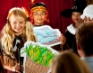
A Feast of Thanksgiving Ideas and Crafts
Go beyond Pilgrim hats and hand turkeys with these 22 fun activities that teach gratitude, charity, friendship, and community.
Read more >
The First Thanksgiving Feast
This book recreates the first harvest feast celebrated by the Pilgrims in 1621 using the Pilgrim and Indian actors and the seventeenth-century setting of Plimoth Plantation, a living history museum in Plymouth, Massachusetts.
Read more >
- Part of Collection:
November Crafts
- Subjects:
Paper Crafts, Thanksgiving, Autumn Themes

