Rainbow R!

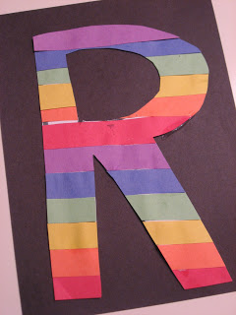
- Gather your materials. You will need multiple pages of construction paper, however you don’t need the whole page, so you may be able to round up enough from your scrap pile. The colors you will needs are red, orange yellow, green, blue and purple. Also you will need a back piece, a plain white sheet of regular paper, scissors, black marker and glue.
- Cut the colored paper into strips, we needed 2 of each color
- Add the glue, this is a great opportunity to let your child do the glue since it needs to be all over and not precise at all.
- Start stacking the strips 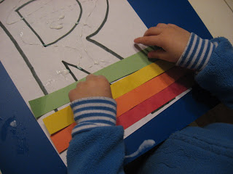
- Let the strips dry on the R
- When dry cut it out following the lines on the back.
- Glue onto a piece of construction paper.
- 