Sight Activity
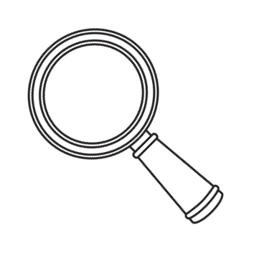
Materials Needed:
✓ Clipboards or Cardboard Squares and Butterfly Clips ✓ Printable Nature Walk Checklist ✓ Pencils or Crayons
Directions:
Print one copy of the nature walk checklist for each child in your classroom.
Students can place the checklist on a clipboard and mark the different things they see on the nature walk with a pencil.
If you don’t have clipboards, you can easily use scraps of cardboard. Just attach the checklists to the cardboard with butterfly clips.

