**WHAT MELTS ICE THE FASTEST?**

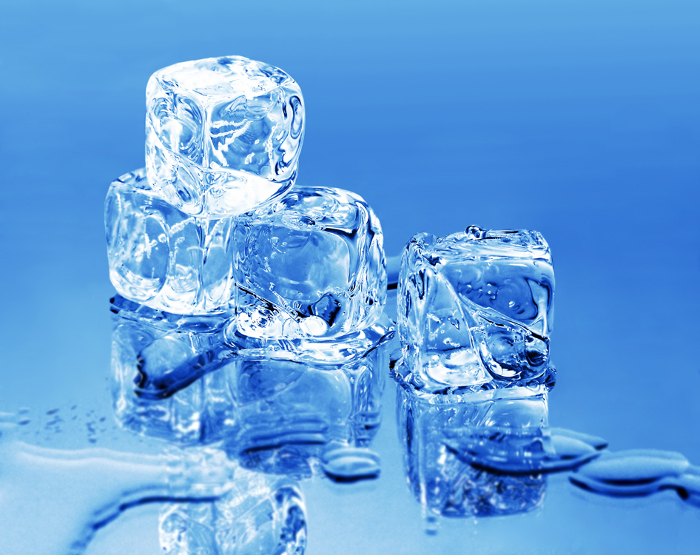

by Tania Gladwell, 1st grade teacher

**WHAT MELTS ICE THE FASTEST?**

**C:\Users\customer\AppData\Local\Microsoft\Windows\Temporary Internet Files\Content.IE5\0COL81CY\MC900012913[1].wmf**

Lesson Submitted by Tania Gladwell, 1st grade teacher

**Objective: In this experiment, students will predict and investigate which materials will or will not melt ice blocks and confirm their predictions by adding each ingredient to a block of ice and record the change.**

**Grade Levels: K-2**

**Materials:**

* **5 Blocks of ice (you can freeze water in Dixie cups or larger containers)**
* **A large pan or plastic container to set the ice blocks on (deep enough to catch the melting water)**
* **Hot water**
* **Baking soda**
* **Sugar**
* **Salt**
* **Vinegar**
* **Liquid water colors OR food coloring**
* **Droppers**
* **Recording sheet (included in lesson)**
* **Magnifying glass**

**Procedure: Begin by having children predict and record which of the ingredients they think will melt the block of ice and why. Test the predictions by adding one ingredient to each block of ice and observe the changes. Children can use a magnifying glass to observe cracks or ravines made in the ice. Record results on the recording sheet. After the children have recorded their findings, use droppers and liquid water colors to apply color to the ice blocks and observe what happens. Why is the color darker in some areas? How did the liquid get inside some of the ice blocks but not all of them? Discuss for example how the salt created cracks in the ice which allowed the color to get inside. Allow the children add more of the ingredients to see what will happen. It’s also fun AND very pretty to add different colors to the same ice block and see what happens to the colors!**

**Name_________** C:\Users\customer\AppData\Local\Microsoft\Windows\Temporary Internet Files\Content.IE5\0COL81CY\MC900012913[1].wmf

**WHAT MELTS ICE THE FASTEST?**

|  |  |  |  |
| --- | --- | --- | --- |
| **What we used…** | **My prediction**  **Will the ice melt?**  **Yes/NO** | **The Experiment**  **Did the ice change or melt?**  **Yes/NO** | **My observation**  **What changes did I see?** |
| **hot water**  C:\Users\customer\AppData\Local\Microsoft\Windows\Temporary Internet Files\Content.IE5\4953C6SA\MC900411958[1].wmf |  |  |  |
| **salt**  C:\Users\customer\AppData\Local\Microsoft\Windows\Temporary Internet Files\Content.IE5\0COL81CY\MP900289628[1].jpg |  |  |  |
| **sugar**  C:\Users\customer\AppData\Local\Microsoft\Windows\Temporary Internet Files\Content.IE5\4953C6SA\MC900325376[1].wmf |  |  |  |
| **vinegar**  C:\Users\customer\AppData\Local\Microsoft\Windows\Temporary Internet Files\Content.IE5\3CA8OCMD\MC900352449[1].wmf |  |  |  |
| **Baking soda**  baking-soda-box-md.png |  |  |  |